Image processing GUI program

1. Decription

* Edge detection, MRI reconstruction, image processing 등의 기능이 있는 GUI program.
* 사용 언어 = C#

1. Display lena image

* Open 8-bit -> lena_256 -> 0k

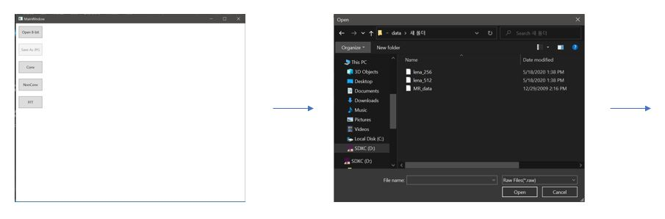

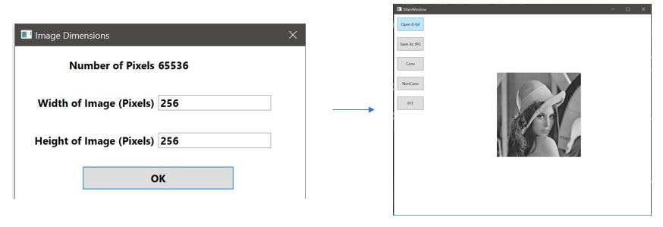

1. Edge detection

* Conv -> lena_256 -> ok -> click something



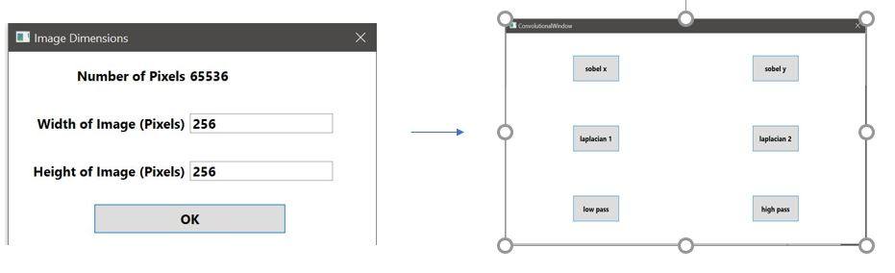

* Image processing

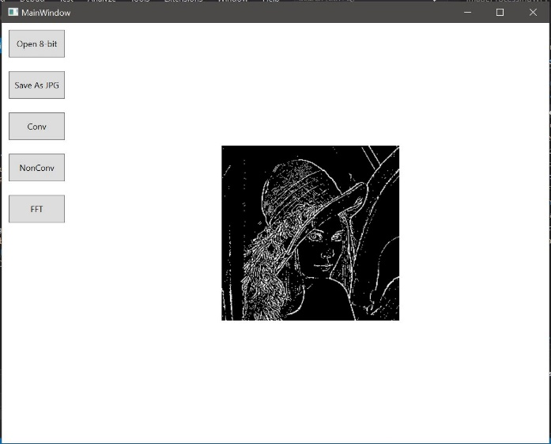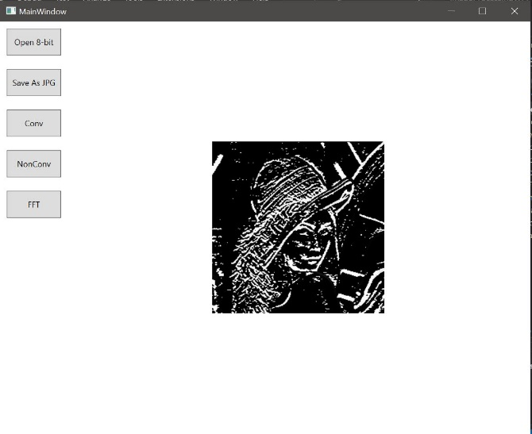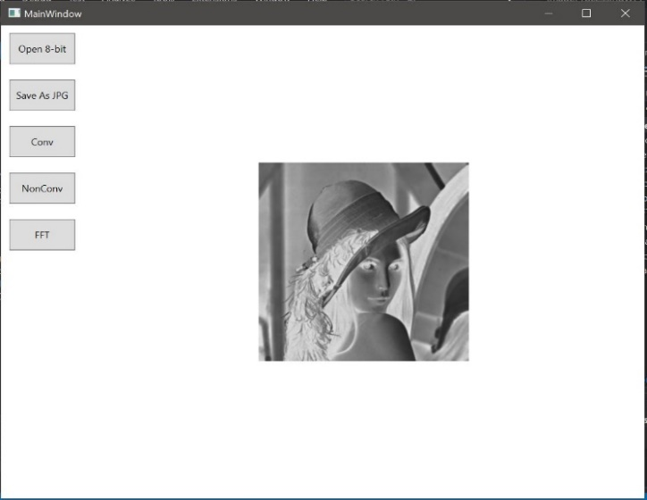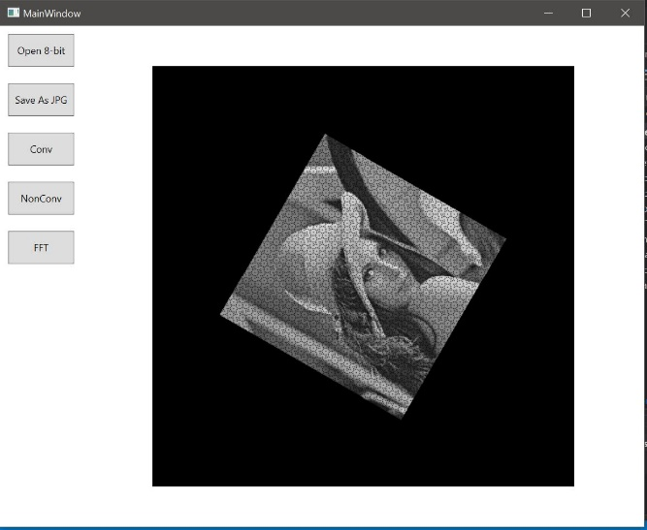

Sobel y

Laplacian 1

Inversion

Rotation

1. Display MRI

* FFT -> Mri -> MR_data -> width of image (Pixels) = 512 , Height of Image (Pixels) = 256

